# VISVESVARAYA TECHNOLOGICAL UNIVERSITY

## BELAGAVI – 590018, Karnataka INTERNSHIP REPORT

#### ON

“Blockchain-Based Voting System”

***Submitted in partial fulfilment for the award of degree***

## BACHELOR OF ENGINEERING IN

## YOUR BRANCH

***Submitted by:***

**Omkar Kallekar**

**2BU21CS407**



Conducted at

**VARCONS TECHNOLOGIES PVT. LTD.**



# SG BALEKUNDRI INSTITUTE OF TECHNOLOGY

**Department of Computer Science and Engineering**

**Accredited by NBA, New Delhi**

# Shivabasava nagar Belagavi - 590010

# SG BALEKUNDRI INSTITUTE OF TECHNOLOGY

**Department of Computer Science and Engineering**

**Accredited by NBA, New Delhi**

# Shivabasava nagar Belagavi - 590010



**CERTIFICATE**

This is to certify that the Internship titled **“Blockchain-Based Voting System”** carried out by **Mr. Omkar Kallekar,** a bonafide student of SG Balekundri Institute of Technology, in partial fulfillment for the award of **Bachelor of Engineering**, in **Computer Science and Engineering** under Visvesvaraya Technological University, Belagavi, during the year 2023-2024. It is certified that all corrections/suggestions indicated have been incorporated in the report. The project report has been approved as it satisfies the academic requirements in respect of Internship prescribed for the course Internship.

#### Signature of Guide Signature of HOD Signature of Principal

**External Viva:**

Name of the Examiner Signature with Date

1)

2)

# DECLARATION

I, **Omkar Kallekar**, final year student of computer science and engineering, SG Balekundri Institute of Technology Belagavi – 590 010, declare that the Internship has been successfully completed, in **Varcons Technologies pvt. ltd**. This report is submitted in partial fulfillment of the requirements for award of Bachelor Degree in Computer Science and Engineering, during the academic year 2023-2024.

Date: December 5, 2023 :

Place: Belagavi.

USN: 2BU21CS407

NAME: Omkar Kallekar

**OFFER LETTER PROVIDED BY THE COMPANY**

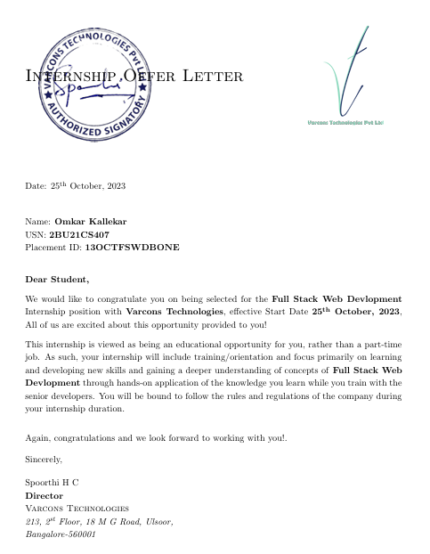

# ACKNOWLEDGEMENT

This Internship is a result of accumulated guidance, direction and support of several important persons. We take this opportunity to express our gratitude to all who have helped us to complete the Internship.

We express our sincere thanks to our Principal, for providing us adequate facilities to undertake this Internship.

We would like to thank our Head of Dept – CSE, for providing us an opportunity to carry out Internship and for his valuable guidance and support.

We would like to thank all the faculty members of our department for the support extended during the course of Internship.

We would like to thank the non-teaching members of our dept, for helping us during the Internship.

Last but not the least, we would like to thank our parents and friends without whose constant help, the completion of Internship would have not been possible.

**NAME:** Omkar Kallekar

**USN:** 2BU21CS407

# ABSTRACT

In any democratic country, Voting is a fundamental right of any citizen that enables them to choose the leaders of tomorrow. It gives individuals in a community the facility to voice their opinion. It helps them to realize the importance of citizenship. Online voting systems are software platforms used to securely conduct votes and elections. As a digital platform, they eliminate the need to cast your votes using paper or having to gather in person. They also protect the integrity of your vote by preventing voters from being able to vote multiple times. Electronic voting or e-voting has fundamental benefits over paper based systems such as increased efficiency and reduced errors. The electronic voting system tends to maximize user participation, by allowing them to vote from anywhere and from any device that has an internet connection. The blockchain is an emerging, decentralized, and distributed technology with strong cryptographic foundations that promises to improve different aspects of many industries. Expanding e-voting into blockchain technology could be the solution to alleviate the present concerns in e-voting. Here we propose a blockchain-based voting system that will limit the voting fraud and make the voting process simple, secure and efficient.

# Table of Contents

|  |  |  |
| --- | --- | --- |
| **Sl no** | **Description** | **Page no** |
| 1 | Company Profile | 8 |
| 2 | About the Company | 10 |
| [3](https://1.bp.blogspot.com/-dODuK8N5h1Q/Wlnyb3V9HFI/AAAAAAAACL4/WxQtCJ1pM5wccDABg4wIrTBUB0vlikXQQCLcBGAs/s1600/poly1.jpg) | Introduction | 14 |
| [4](https://1.bp.blogspot.com/-dODuK8N5h1Q/Wlnyb3V9HFI/AAAAAAAACL4/WxQtCJ1pM5wccDABg4wIrTBUB0vlikXQQCLcBGAs/s1600/poly1.jpg) | System Analysis | 17 |
| [5](https://1.bp.blogspot.com/-dODuK8N5h1Q/Wlnyb3V9HFI/AAAAAAAACL4/WxQtCJ1pM5wccDABg4wIrTBUB0vlikXQQCLcBGAs/s1600/poly1.jpg) | Requirement Analysis | 20 |
| 6 | Design [Analysis](https://4.bp.blogspot.com/-IOOxgPaXMVc/Wlj3LWvcnjI/AAAAAAAACKE/UeTFYvAxDmUDel5UBjdifeWaApB3-dXVgCLcBGAs/s1600/img1.jpg) | 23 |
| 7 | [Implementation](https://4.bp.blogspot.com/-IOOxgPaXMVc/Wlj3LWvcnjI/AAAAAAAACKE/UeTFYvAxDmUDel5UBjdifeWaApB3-dXVgCLcBGAs/s1600/img1.jpg) | 25 |
| 8 | Snapshots | 27 |
| 9 | Conclusion | 30 |
| 10 | References | 33 |

[**CHAPTER**](https://1.bp.blogspot.com/-dODuK8N5h1Q/Wlnyb3V9HFI/AAAAAAAACL4/WxQtCJ1pM5wccDABg4wIrTBUB0vlikXQQCLcBGAs/s1600/poly1.jpg) **1** **COMPANY PROFILE**

# COMPANY PROFILE

## A Brief History of Company

Varcons Technologies, was incorporated with a goal ”To provide high quality and optimal Technological Solutions to business requirements of our clients”. Every business is a different and has a unique business model and so are the technological requirements. They understand this and hence the solutions provided to these requirements are different as well. They focus on clients requirements and provide them with tailor made technological solutions. They also understand that Reach of their Product to its targeted market or the automation of the existing process into e-client and simple process are the key features that our clients desire from Technological Solution they are looking for and these are the features that we focus on while designing the solutions for their clients.

Varcons Technologies, is a Technology Organization providing solutions for all web design and development, MYSQL, PYTHON Programming, HTML, CSS, ASP.NET and LINQ. Meeting the ever increasing automation requirements, Varcons Technologies, specialize in ERP, Connectivity, SEO Services, Conference Management, effective web promotion and tailor-made software products, designing solutions best suiting clients requirements.

Varcons Technologies, strive to be the front runner in creativity and innovation in software development through their well-researched expertise and establish it as an out of the box software development company in Bangalore, India. As a software development company, they translate this software development expertise into value for their customers through their professional solutions.

They understand that the best desired output can be achieved only by understanding the clients demand better. Company work with their clients and help them to defiine their exact solution requirement. Sometimes even they wonder that they have completely redefined their solution or new application requirement during the brainstorming session, and here they position themselves as an IT solutions consulting group comprising of high caliber consultants.

They believe that Technology when used properly can help any business to scale and achieve new heights of success. It helps Improve its efficiency, profitability, reliability; to put it in one sentence ” Technology helps you to Delight your Customers” and that is what we want to achieve.

# [CHAPTER](https://1.bp.blogspot.com/-dODuK8N5h1Q/Wlnyb3V9HFI/AAAAAAAACL4/WxQtCJ1pM5wccDABg4wIrTBUB0vlikXQQCLcBGAs/s1600/poly1.jpg) 2 ABOUT THE COMPANY

1. **ABOUT THE COMPANY**

Varcons Technologies is a Technology Organization providing solutions for all web design and development, MYSQL, PYTHON Programming, HTML, CSS, ASP.NET and LINQ. Meeting the ever increasing automation requirements, Company specialize in ERP, Connectivity, SEO Services, Conference Management, effective web promotion and tailor-made software products, designing solutions best suiting clients requirements. The organization where they have a right mix of professionals as a stakeholders to help us serve our clients with best of our capability and with at par industry standards. They have young, enthusiastic, passionate and creative Professionals to develop technological innovations in the field of Mobile technologies, Web applications as well as Business and Enterprise solution. Motto of our organization is to “Collaborate with our clients to provide them with best Technological solution hence creating Good Present and Better Future for our client which will bring a cascading a positive effect in their business shape as well”. Providing a Complete suite of technical solutions is not just our tag line, it is Our Vision for Our Clients and for Us, We strive hard to achieve it.

## Products of Company.

**Android Apps**

It is the process by which new applications are created for devices running the Android operating system. Applications are usually developed in Java (and/or Kotlin; or other such option) programming language using the Android software development kit (SDK), but other development environments are also available, some such as Kotlin support the exact same Android APIs (and bytecode), while others such as Go have restricted API access.

The Android software development kit includes a comprehensive set of development tools. These include a debugger, libraries, a handset emulator based on QEMU, documentation, sample code, and zutorials. Currently supported development platforms include computers running Linux (any modern desktop Linux distribution), Mac OS X 10.5.8 or later, and Windows 7 or later. As of March 2015, the SDK is not available on Android itself, but softwaredevelopment is possible by using specialized Android applications.

**Web Application**

It is a client–server computer program in which the client (including the user interface and client- side logic) runs in a web browser. Common web applications include web mail, online

retail sales, online auctions, wikis, instant messaging services and many other functions. web applications use web documents written in a standard format such as HTML and JavaScript,which are supported by a variety of web browsers. Web applications can be considered as a specifific variant of client–server software where the client software is downloaded to the client machine when visiting the relevant web page, using standard procedures such as HTTP. The Client web software updates may happen each time the web page is visited. During the session, the web browser interprets and displays the pages, and acts as the universal client for any web application. The use of web application frameworks can often reduce the number of errors in a program, both by making the code simpler, and by allowing one team to concentrate on the framework while another focuses on a specifified use case. In applications which are exposed to constant hacking attempts on the Internet, security- related problems can be caused by errors in the program.

Frameworks can also promote the use of best practices such as GET after POST. There are some who view a web application as a two-tier architecture. This can be a “smart” client that performs all the work and queries a “dumb” server, or a “dumb” client that relies on a “smart” server. The client would handle the presentation tier, the server would have the database (storage tier), and the business logic (application tier) would be on one of them or on both. While this increases the scalability of the applications and separates the display and the database, it still doesn‟t allow for true specialization of layers, so most applications will outgrow this model. An emerging strategy for application software companies is to provide web access to software previously distributed as local applications. Depending on the type of application, it may require the development of an entirely different browser-based interface, or merely adapting an existing application to use different presentation technology. These programs allow the user to pay a monthly or yearly fee for use of a software application without having to install it on a local hard drive. A company which follows this strategy is known as an application service provider (ASP), and ASPs are currently receiving much attention in the software industry.

Security breaches on these kinds of applications are a major concern because it can involve both enterprise information and private customer data. Protecting these assets is an important part of any web application and there are some key operational areas that must be included in the development process. This includes processes for authentication, authorization, asset handling, input, and logging and auditing. Building security into the applications from the beginning can be more effective and less disruptive in the long run.

**Web design**

It is encompasses many different skills and disciplines in the production and maintenance of websites. The different areas of web design include web graphic design; interface design; authoring, including standardized code and proprietary software; user experience design; and

search engine optimization. The term web design is normally used to describe the design process relating to the front-end (client side) design of a website including writing mark up. Web design partially overlaps web engineering in the broader scope of web development. Web designers are expected to have an awareness of usability and if their role involves creating mark up then they are also expected to be up to date with web accessibility guidelines. Web design partially overlaps web engineering in the broader scope of web development.

## Departments and services offered

Company plays an essential role as an institute, the level of education, development of student’s skills are based on their trainers. If you do not have a good mentor then you may lag in many things from others and that is why we at Company gives you the facility of skilled employees so that you do not feel unsecured about the academics. Personality development and academic status are some of those things which lie on mentor’s hands. If you are trained well then you can do well in your future and knowing its importance of Company always tries to give you the best.

They have a great team of skilled mentors who are always ready to direct their trainees in the best possible way they can and to ensure the skills of mentors we held many skill development programs as well so that each and every mentor can develop their own skills with the demands of the companies so that they can prepare a complete packaged trainee.

## Services provided by Company.

* Core Java and Advanced Java
* Web services and development
* Dot Net Framework
* Python
* Selenium Testing
* Conference / Event Management Service
* Academic Project Guidance
* On The Job Training
* Software Training

# [CHAPTER](https://1.bp.blogspot.com/-dODuK8N5h1Q/Wlnyb3V9HFI/AAAAAAAACL4/WxQtCJ1pM5wccDABg4wIrTBUB0vlikXQQCLcBGAs/s1600/poly1.jpg) 3 INTRODUCTION

1. **INTRODUCTION**

## Introduction to Web Apps

Web applications are similar to the traditional applications you’d install on your Information, such as Microsoft Office. They are able to perform the same kinds of tasks, they look the same and they feel the same but there is one key difference - the application itself is not installed on your phone or Information, but lives in the cloud. Web apps are not new, but it used to be that they were often unable to compete with more traditional applications for business critical functions or where rich user interaction was required. This is no longer the case. With the power of modern web technologies, we are able to design and build performing, secure, and feature rich applications that live in the cloud and bring with them a huge number of benefits.

#### They can be accessed from anywhere.

* Because web applications are built with web technologies and they run in a web browser Internet Explorer, Google Chrome, Mozilla Firefox – this allows them to be accessed from every web enabled tool. As long as you have an internet connection you can use them.
* It allows for remote working, it allows for rapid publishing of content, it allows for real time collaboration between teams. If you have web access, you have the ability to access your business tools.

#### They are cost effective.

* Web applications are cheaper to produce and maintain than traditional applications. No matter how many platforms your business uses (Mac, Linux, Windows) web application build can be used across them all.

#### They benefit from more rapid update cycles.

* A huge benefit of web applications is that when an update is released, all of your users are immediately using that version. This doesn’t happen with installed applications, especially in large organizations with IT policies that restrict administrator access.

#### They are secure.

* Web developers have had to become experts in security – the web is a platform designed to share everything with everyone! As such, the types and levels of security included in web applications are often far greater than those seen in traditional applications.
* They also benefit from the ability to launch updates in real-time – the application on the servers is the application people are using. The applications on people’s laptops however is the version last installed. And when those laptops get left on a train it’s not a concern, as nothing is stored locally.

#### They enable more computing with fewer Information.

* Web applications push all of the hard work to the servers, and act as intermediaries between the user interface and the calculations happening behind the scenes. This means you can accomplish terrifyingly complex work on a tablet, or your phone.
* We’ve built web applications that allow people to understand the complex relationships between 250,000 pieces of art on their phones, and applications that run the business systems of one of the largest solar energy providers in the world. Often these products are not financially viable to build using traditional application processes.

# [CHAPTER](https://1.bp.blogspot.com/-dODuK8N5h1Q/Wlnyb3V9HFI/AAAAAAAACL4/WxQtCJ1pM5wccDABg4wIrTBUB0vlikXQQCLcBGAs/s1600/poly1.jpg) 4 SYSTEM ANALYSIS

**4. SYSTEM ANALYSIS**

## Existing System

The Existing System of Election is running manually. The Voter has to Visit to Booths to Vote a Candidate so there is wastage of Time. Due to this many people don’t go out to cast their vote which is one of the most important and Worrying factor. In democracy Each and every vote is important. This Traditional system can be replaced by a new online system which will limit the voting frauds and make the voting as well as counting more efficient and transparent.

## Proposed System

## The current voting system requires some improvement in it because of the issues mentioned above. This can be achieved by replacing the existing system by the new system which will limit the voting frauds and make the voting as well as counting more efficient.

## Online Election System would have user registration, user login and admin login.

## This Online Voting System will manage the Voter’s information by which voter can login and use his voting rights.

## At the time of registration voter will be asked for this: Full name, age, Aadhaar card no, mobile no. email id and after being verified will be given the access.

## At the time of requesting vote, voter will be asked to enter his Aadhaar id. Then voter will be authenticated, and he can give vote from one of the candidate from the list .Voters can vote for a Candidate only once per Election.

## The software system allows the user to login in to their profiles and upload all their details including their previous milestone onto the system. The admin can check each Candidate details.

## The software system also allows Voters to view a list of Candidates in their area. The admin has overall rights over the system and can moderate and delete any details not pertaining to Election Rules.

## Objective of the System

1. Increasing the level of participation, The Internet voting system tends to maximize user participation, by allowing them to vote from anywhere and from any device that has an internet connection.
2. Security By considering the importance of the e-voting system is implemented using “Blockchain”.
3. Efficiency The reduction in organizational and implementation costs significantly increases the efficiency of election management compared to traditional paper voting, for example.
4. Precision The electronic vote eliminates errors in manual count, which brings with it an accurate and quick publication of results, with receipt of vote for each vote cast.

# [CHAPTER](https://1.bp.blogspot.com/-dODuK8N5h1Q/Wlnyb3V9HFI/AAAAAAAACL4/WxQtCJ1pM5wccDABg4wIrTBUB0vlikXQQCLcBGAs/s1600/poly1.jpg) 5 REQUIREMENT ANALYSIS

**5. REQUIREMENT ANALYSIS**

## Hardware Requirement Specification

* + Processor: Intel core i5 processer
  + Memory: 15.6 GB
  + Hard Disk: 40 GB

## Software Requirement Specification

### Functional Requirements

* + Voter Authentication:
    - Secure and user-friendly authentication methods.
    - Verification of voter eligibility through registration.
  + Ballot Security:
    - Generation of tamper-proof digital ballots.
    - Distribution of ballots to eligible voters securely.
  + Transparent and Immutable Record:
    - Integration with a blockchain for transparent and immutable vote recording.
    - Timestamping for transaction order.
  + Smart Contracts:
    - Use of smart contracts for automated and rule-based execution.
    - Auto-validation of votes based on predefined criteria.
  + Security Measures:
    - Implementation of strong cryptographic techniques.
    - Protection against DDoS attacks.
  + Results Tabulation:
    - Real-time counting and display of results.
    - Mechanisms for verifying result accuracy.

### Non-Functional Requirements

#### Availability

The online registration system shall permit backing up of the registration database while other registration actives are going on.

#### Accessibility

The system shall be accessible by people with specific vision needs to the extent that a user shall be able to display whole user interface in a larger font without truncating displayed text or other values.

#### Security

The access permissions for system data may only be change by the systems data administrator passwords shall never be viewable at the point of entry or any other time.

# [CHAPTER](https://1.bp.blogspot.com/-dODuK8N5h1Q/Wlnyb3V9HFI/AAAAAAAACL4/WxQtCJ1pM5wccDABg4wIrTBUB0vlikXQQCLcBGAs/s1600/poly1.jpg) 6 DESIGN ANALYSIS

1. **DESIGN & ANALYSIS**

The existing system for voting in India is the EVM (Electronic Voting Machine) based system. Prior to this system there were paper ballots and manual counting. The paper ballots method was widely criticized because of fraudulent voting and booth capturing, where party loyalists captured booths and stuffed them with pre-filled fake ballots. Replacing the existing system with a new election system is critical to limit fraud and having the voting process traceable and verifiable. As we can see the internet has brought a revolution in each and every domain possible, by trying to shift the existing system towards the online platform to make the proceedings fast and user convenient. We know that the existing system is reliable but that does not mean that we should not take a step ahead towards the betterment of the existing system. Online voting system using blockchain can be that step. A blockchain is a distributed, immutable, incontrovertible, public ledger. This new technology works through four main features:

* The ledger exists in many different locations: No single point of failure in the maintenance of the distributed ledger.
* There is distributed control over who can append new transactions to the ledger.
* Any proposed “new block” to the ledger must reference the previous version of the ledger, creating an immutable chain from where the blockchain gets its name, and thus preventing tampering with the integrity of previous entries.

We have tried to build a user interface of the decentralized application that will make the voting process more convenient. The UI portion can be assumed as 30% of the total work that is to be completed. The major portion in this system is related to the blockchain technology which will be responsible for the reliable voting process.

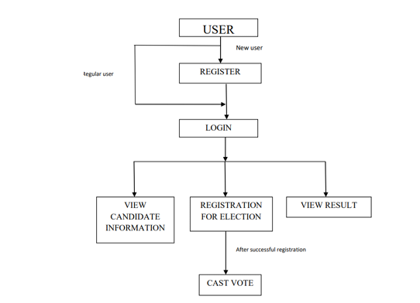

**Figure: 6.1:** User flow diagram

# [CHAPTE](https://1.bp.blogspot.com/-dODuK8N5h1Q/Wlnyb3V9HFI/AAAAAAAACL4/WxQtCJ1pM5wccDABg4wIrTBUB0vlikXQQCLcBGAs/s1600/poly1.jpg)R 7 IMPLEMENTATION

1. **IMPLEMENTATION**

Implementation is the stage where the theoretical design is turned into a working system. The most crucial stage in achieving a new successful system and in giving confidence on the new system for the users that it will work efficiently and effectively.

The system can be implemented only after thorough testing is done and if it is found to work according to the specification. It involves careful planning, investigation of the current system and it constraints on implementation, design of methods to achieve the change over and an evaluation of change over methods a part from planning.

Two major tasks of preparing the implementation are education and training of the users and testing of the system. The more complex the system being implemented, the more involved will be the system analysis and design effort required just for implementation.

The implementation phase comprises of several activities. The required hardware and software acquisition is carried out. The system may require some software to be developed. For this, programs are written and tested. The user then changes over to his new fully tested system and the old system is discontinued.

## TESTING

The testing phase is an important part of software development. It is the Information zed system will help in automate process of finding errors and missing operations and also a complete verification to determine whether the objectives are met and the user requirements are satisfied. Software testing is carried out in three steps:

1. The first includes unit testing, where in each module is tested to provide its correctness, validity and also determine any missing operations and to verify whether the objectives have been met. Errors are noted down and corrected immediately.
2. Unit testing is the important and major part of the project. So errors are rectified easily in particular module and program clarity is increased. In this project entire system is divided into several modules and is developed individually. So unit testing is conducted to individual modules.
3. The second step includes Integration testing. It need not be the case, the software whose modules when run individually and showing perfect results, will also show perfect results when run as a whole.

# [CHAPTE](https://1.bp.blogspot.com/-dODuK8N5h1Q/Wlnyb3V9HFI/AAAAAAAACL4/WxQtCJ1pM5wccDABg4wIrTBUB0vlikXQQCLcBGAs/s1600/poly1.jpg)R 8 SNAPSHOTS

* 1. **SNAPSHOTS**

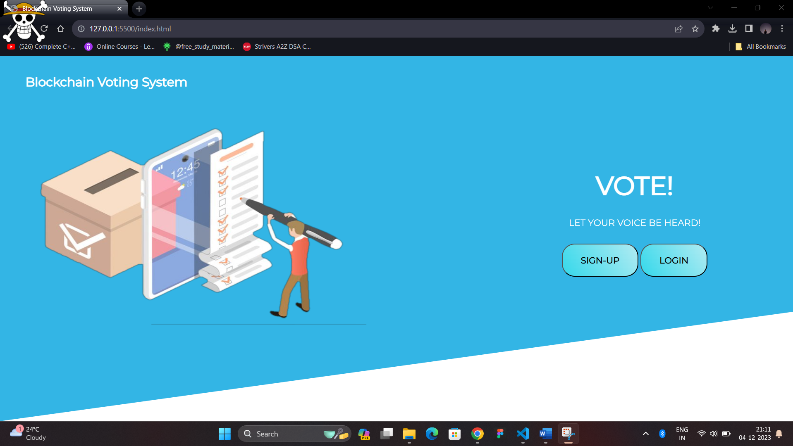

**Figure 8.1:** Homepage

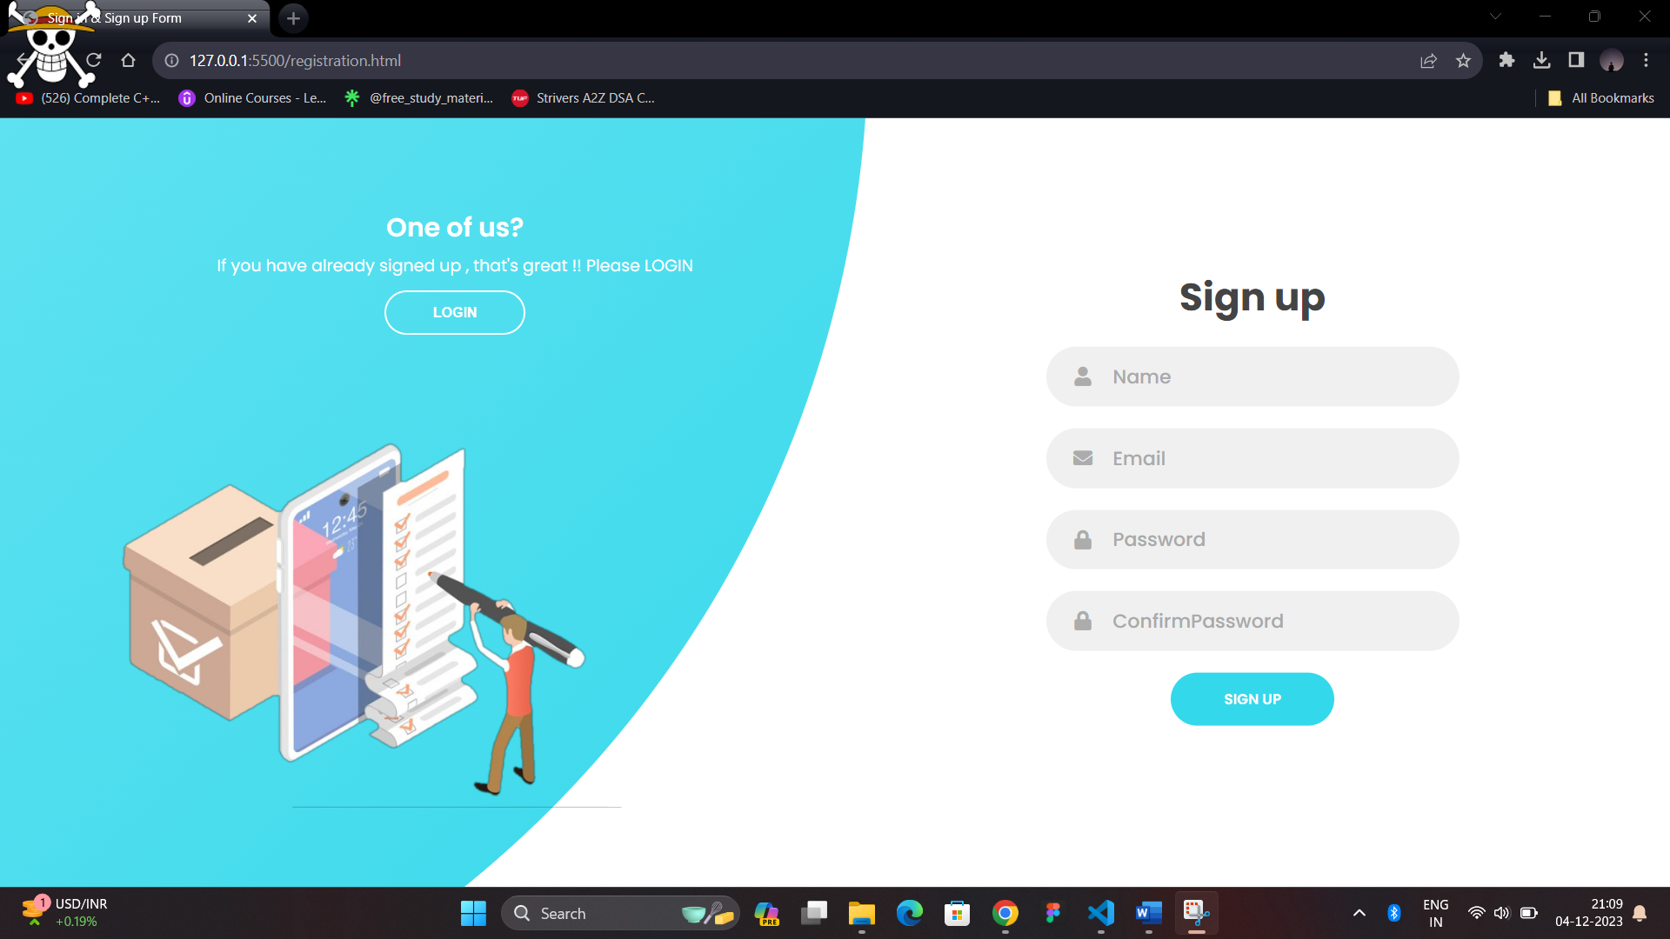

**Figure 8.2:** Sign Up page

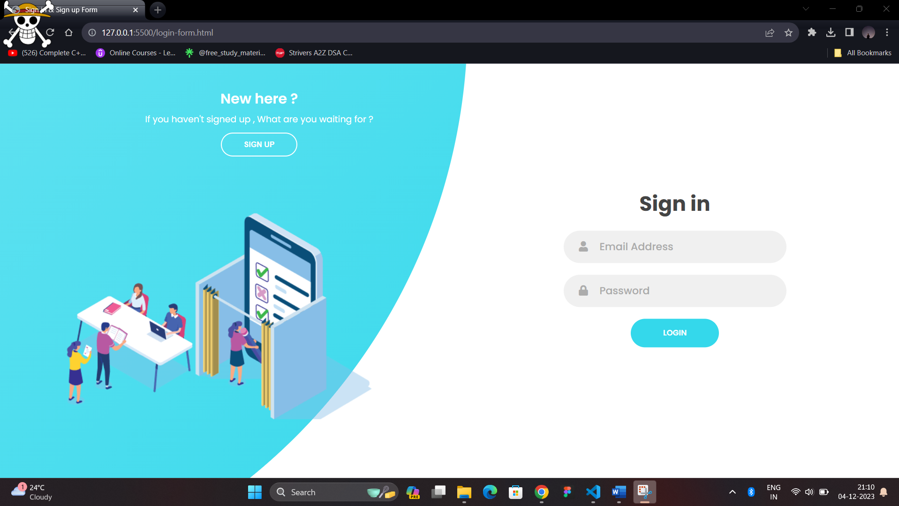

**Figure 8.3:** Log in page

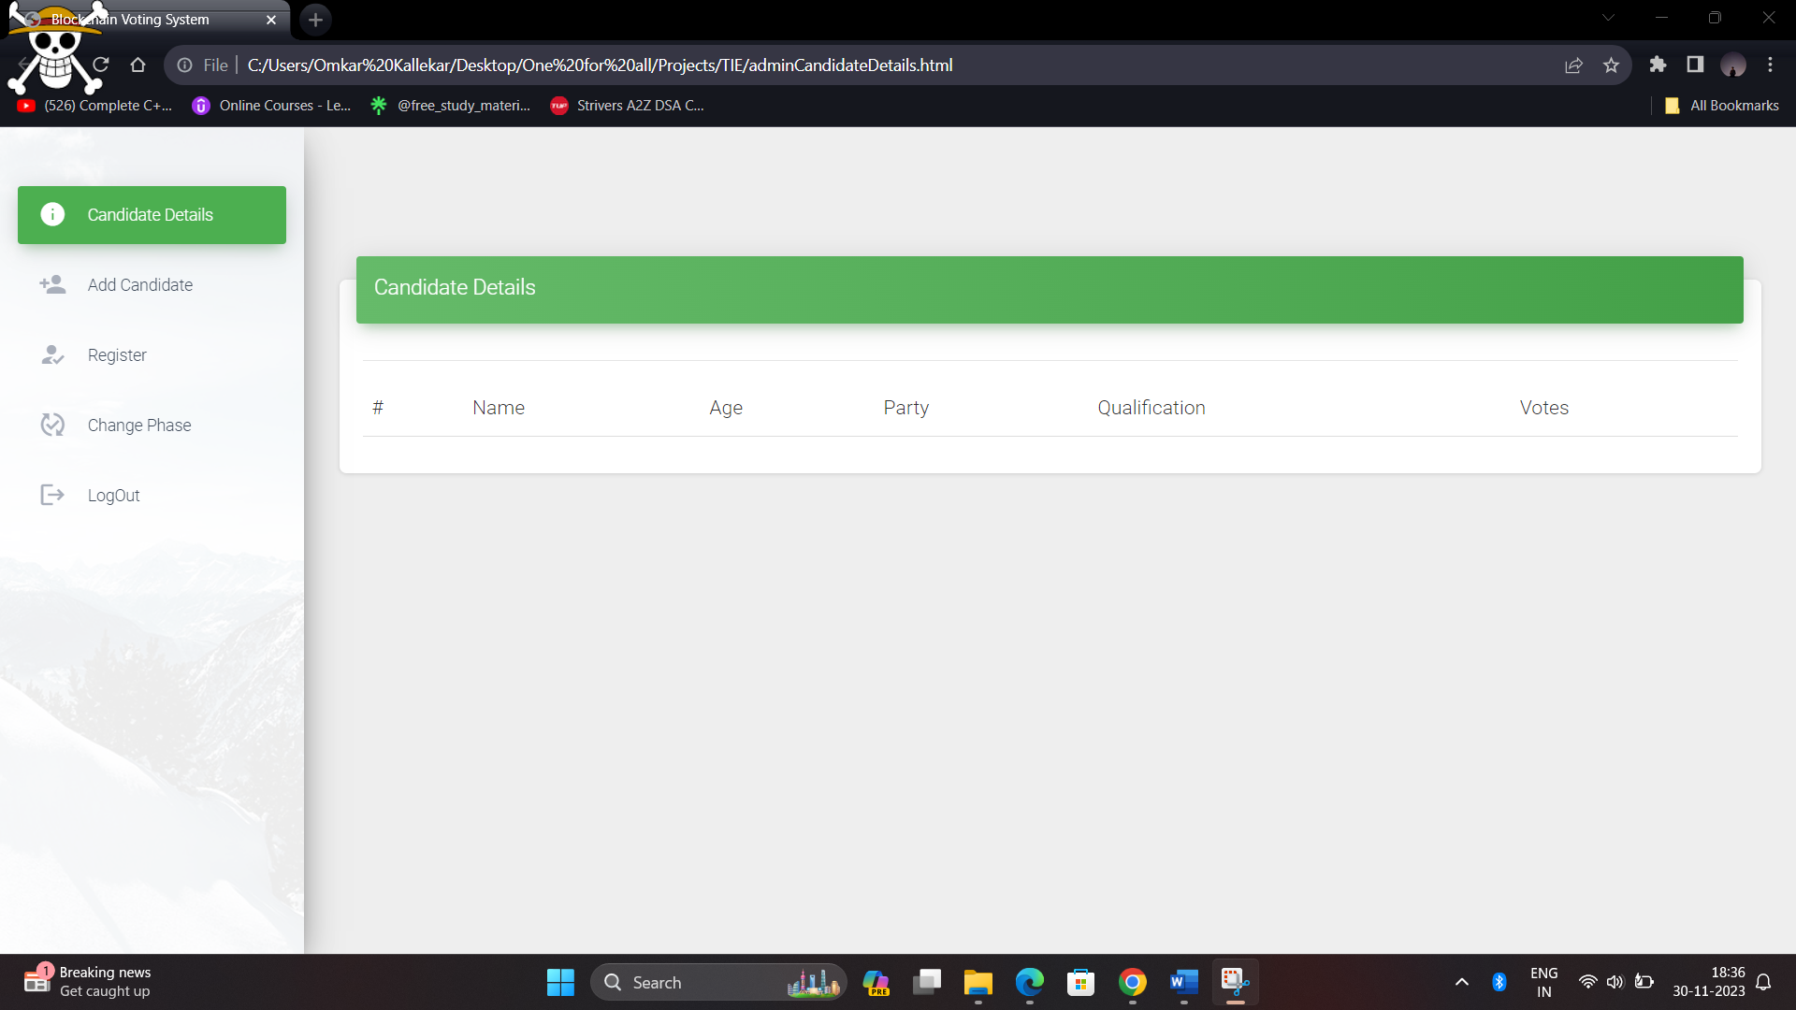

**Figure 8.4:** Candidate details page

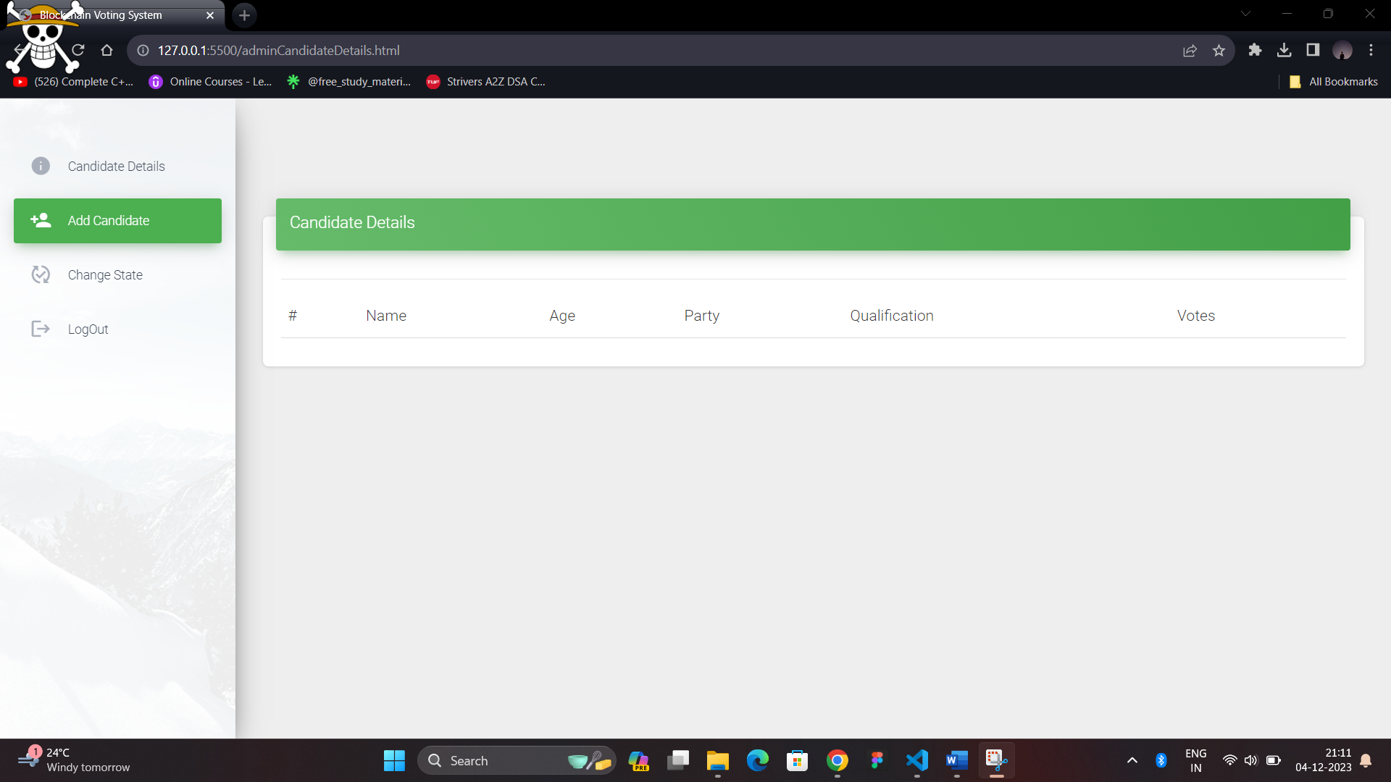

**Figure 8.5:** Adding new candidate.

# [CHAPTE](https://1.bp.blogspot.com/-dODuK8N5h1Q/Wlnyb3V9HFI/AAAAAAAACL4/WxQtCJ1pM5wccDABg4wIrTBUB0vlikXQQCLcBGAs/s1600/poly1.jpg)R 9 CONCLUTION

* 1. **CONCLUTION**

In this project, we introduced a blockchain-based electronic voting system that utilizes smart contracts to enable secure and cost-efficient election while guaranteeing voters privacy. Blockchain technology offers a new possibility to overcome the limitations and adoption barriers of electronic voting systems which ensures the election security and integrity and lays the ground for transparency. Using an Ethereum private blockchain, it is possible to send hundreds of transactions per second onto the blockchain, utilizing every aspect of the smart contract to ease the load on the blockchain. To achieve this, we have divided this overall work into three modules.

1. The front-end module

2. The back-end module

3. Connection of two different module along with the testing.

Until now we have completed our first module, in which we created the interactive user interface for the admin as well as the user. We have also done some research work related to the implementation of Blockchain in decentralized application. And In the future to make the voting process more secure and to correctly identify the person who is voting we can use ML and AI concepts. Using these concepts we can verify whether the person voting is the same as the person who has registered during the registration process.

# REFERENCE

[1] Coursera. [Online]. Available: https://www.coursera.org/specializations/blockchaina

[2] Edureka (How Blockchain Works) - Simply Explained. [Online]. Available:https://youtu.be/9qfxLo1rt1Q?list=PL9ooVrP1hQOFJblZm3OdcVVH 6Z8V7HP1

[3] Introduction to Blockchain by NPTEL IITM. [Online] Available: <https://youtu.be/mzPoUjQC4WU>

[4] Blockchain in e-voting. [Online]. Available: https://www.youtube.com/watch? v=d0iLN8LDJ8g&feature=youtu.be

[5] Umut Can Çabuk1, Eylül Adıgüzel2, Enis Karaarslan2 (2018); A Survey on Feasibility and Suitability of Blockchain Techniques for the E-Voting Systems; International Journal of Advanced Research in Computer and Communication Engineering. [Online]. Available:https://www.researchgate.net/publication/324038634_A_Survey_on_F easibility_and_Suitability_of_Blockchain_Techniques_for_the_E Voting_Systems

[6] Aayushi Gupta1, Jyotirmay Patel2, Mansi Gupta1, Harshit Gupta1 (2017); Issues and Effectiveness of Blockchain Technology on Digital Voting; International Journal of Engineering and Manufacturing Science. ISSN 2249-3115 Vol. 7, No. 1 (2017). [Online]. Available:https://www.ripublication.com/ijems_spl/ijemsv7n1_04.pdf

[7] Pavel Tarasov and Hitesh Tewari (2017); the Future of E-Voting; IADIS International Journal on Computer Science and Information Systems Vol.12, No. 2, pp. 148 165 I. [Online]. Available:https://www.researchgate.net/publication/321803764_THE_FUTURE _OF_EVOTING